Button Hero

DM2623 Project Report 2020

Gracia Yuwono Kwantalalu  
 graciayk@kth.se

ABSTRACT

Children with profound intellectual disabilities find it challenging and have minimal opportunities to interact with other children. As collaboration is an important aspect of life, we want to enable and encourage these children to do so. We aim to achieve this by building an accessible musical instrument, which can be played together. The musical instrument consists of three buttons which would light up and when pressed, it will play a part of a song. Also, a digital form of this musical instrument, which applies the same concept, was developed.

1 Introduction and Background

While visiting Rullen, we noticed that the children with profound intellectual and physical disabilities do not have much opportunity to interact with one another. We think that an easy and fun way to enable collaboration between them is through playing music together. Our project aims to create an accessible musical instrument which allows these children to play music together with minimum effort required.

**1.1 Background**

According to Article 27 of the Declaration of the Human Rights (1948), “Everyone has the right to freely participate in the cultural life of the community…” This declaration suggests that everyone, regardless of abilities or disabilities, should be able to play music if they want to.

With the declaration in mind, great progress has been made in the area of accessible musical instruments. This is because many researchers have found that there are many benefits which musical therapy can offer to people with intellectual disabilities. These benefits include, but is not limited to, improving communication, cognition, physical development and emotional development (Hooper et al., 2008).

Over the past few years, there has been a steady increase in the availability of assistive music technology (AMT) and accessible Digital Musical Instruments (DMIs) for people with intellectual disabilities (Samuels, 2014). These technology and instruments are a great enabler of music-playing for people with intellectual disabilities.

However, our group feels that a simpler and more fun musical instrument would be more suitable for children with profound intellectual and physical disabilities. These elements would make it easier for the children to collaborate in playing music.

**1.2 Ethical considerations**

Some ethical considerations include ensuring that our target users, who are the children with profound intellectual and physical disabilities in Rullen, are treated with respect and dignity. We ensured that they were not subjected to harm or discomfort in any ways at all time. We did this by seeking for an approval from the school authority, as well as the course coordinator, before proceeding with this project. During this process, all information related to the project was communicated accurately.

2 Method

The simple, fun and collaborative musical instrument which our group has come up with is called the “Button Hero”. For this project, we have created the physical and the digital form of the musical instrument.

**2.1 Implementation**

The physical “Button Hero” is based on Bela as the computing hardware and it uses Faust as the programming language. Buttons with built-in LEDs and loudspeakers are connected to the Bela board. Thus, the materials used to create this musical instrument consist of a Bela board, three buttons, three speakers, and some wires and transistors. We also built three wooden casings using a laser cut to contain the button, speaker and wires.

For this project, we programmed the musical instrument to play a children song. This song could easily be changed according to the likes of the children. The duration of the song which is triggered by a press of a button could also be adjusted for instance from 3 seconds to 5 seconds. We could also adjust the time in which the button lights up, for example 1 second or 3 seconds before the song fades out. These parameters allow the caretakers to adjust the difficulty level of the game, which enables them to accommodate a wider range of abilities, hence, making it more accessible to more people with different level of intellectual and physical abilities.

The digital “Button Hero” uses JavaScript for the programming language and Howler.JS to control the audio. In addition, to facilitate communication between multiple devices and synchronize the songs between them, we used Firebase Realtime Database. In this part, the “button” is implemented on the webpage, hence, only a device with internet (e.g. computer or phone) is needed to play the game.

**2.2 Group Work**

We worked together well as a group. The project idea was collaboratively thought out and modified along the way with inputs from all group members.

Due to the diversity of skills and the different demands of the project, each of our project members worked on different parts of the project according to our skills. Teun Loeffen, Annika Neumann, and Levi Villarreal were mainly responsible for assembling the musical instrument. Gracia Yuwono Kwantalalu and Josephine Lantz were mainly responsible for the report.

3 Results and Analysis

For the physical form, “Button Hero” consists of three movable wooden boxes with a button on each of it. To encourage collaboration, each child, in a group of three at a time, will be holding onto one of the wooden boxes. In order to play the whole song, the different buttons need to be pressed. The next button to press is randomized and is indicated by an LED light. When the lit button is pressed, the next few seconds of the song will continue to play. As such, all of the children will get the chance to participate in the activity and be a part of a collaboration.

The light to indicate which button to press adds an element of fun as children respond positively to light. This would also allow children who have difficulties recognizing songs to still be able to join the music playing activity.

Figure 1: Button Hero (Physical Form)

For the digital form, each child will be given a device which is able to open our musical instrument web application (<https://instrument-71113.firebaseapp.com/?fbclid=IwAR1FBm3zEwpOx999KjY4DFCML8VkynLXaWTLGIyodfDfY4YHa81mX0iq9YY>). Similar to the physical form, the children will have to collaborate by tapping their screens when they turn green in order to play the whole song. The digital “Button Hero” is more scalable than the physical one as it is able to accommodate as many devices as desired.

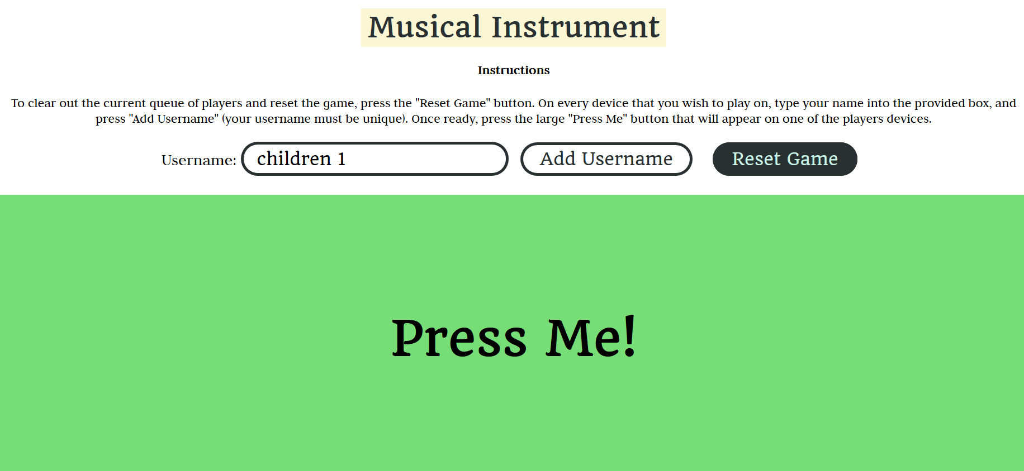

Figure 2: Button Hero (Digital Form)

Considering the design of our musical instrument, we hope that the children at Rullen would show enthusiasm towards this novel musical instrument, especially the fact that the buttons light up and sounds come out when the buttons are pressed. We can foresee that not all of the children would be able to grasp the concept of music, which was why we put in the element of light. We hope that this visual cue would help them to still be able to participate in the game. Therefore, although the children are not verbally communicating with each other, they will still be able to collaborate with each other. Furthermore, by having a small piece of a song instead of using a single tone every time the button is pressed, makes it easier for the children to recognize the song and the music doesn’t get too abstract.

All in all, we believe that our musical instrument is able to achieve our intended outcome, which is to create an easy and fun medium for children with profound intellectual disabilities to have fun and collaborate with other children through music.

4 Discussion

**4.1 Criticism**

Was the method less than optimal? What were the problems? Could you have solved the task differently?

5 Conclusion

This should be a conclusion that reflects the results and the discussion. A conclusion is usually short. You can include possible future directions.

REFERENCES

[1] Assembly, U.G. Universal Declaration of Human Rights; UN General Assembly: New York, NY, USA, 1948. Available online: https://www.un.org/en/udhrbook/pdf/udhr_booklet_en_web.pdf

[2] Hooper, J., Wigram, T., Carson, D., & Lindsay,B., A review of the music and intellectual disability literature (1943-2006) II: Experimental writing. Music Therapy Perspectives, 26(2), 2008, p. 80-96

[3] Samuels, K. Enabling Creativity: Inclusive Music Interfaces and Practices. In Proceedings of the International Conference on Live Interfaces (ICLI), Lisbon, Portugal, 19–23 November 2014.Conference Name:ACM Woodstock conference

Conference Short Name:WOODSTOCK’18

Conference Location:El Paso, Texas USA

ISBN:978-1-4503-0000-0/18/06

Year:2018

Date:June

Copyright Year:2018

Copyright Statement:rightsretained

DOI:10.1145/1234567890

RRH: F. Surname et al.

Price:$15.00